SIMATS ENGINEERING
ASSESSMENT TOOL 2

Experiments

COURSE NAME: OBJECT ORIENTED ANALYSIS AND DESIGN COURSE CODE: CSA1153

COURSE OUTCOME COVERED

CO3: Analyze system requirements using object-oriented techniques to identify classes, attributes, and relationships and develop use case models. (BL4)

Assessment Tool Weightage: 40%

Annexure A

Code of Conduct:
I Niranjana M (192511240) (Name / Reg No) certify that this submission is my original work and that I have adhered to the guidelines specified for this assessment.
I understand that any violation of academic integrity rules will result in disciplinary action.

Signature of the student:

RUBRICS FOR CALCULATION:

Experiments

Criteria | Weightage | Level 4 – Exemplary | Level 3 – Proficient | Level 2 – Developing | Level 1 – Beginning
Understanding  of Case | 25 | Thorough  understanding;  clearly  identifies all  key issues | Good  understanding  with most  issues  identified | Basic  understanding;  some issues  missed | Poor  understanding;  problem not  identified  correctly
Application of  Concepts | 25 | Effectively  applies  relevant  concepts to  analyze the  case deeply | Applies  appropriate  concepts with  minor gaps | Limited  application of  concepts | Fails to apply  relevant  concepts
Use of Tools | 20 | Effective and advanced use of tools/technologies with  proper configuration | Appropriate use of tools with correct  execution | Limited or inconsistent use of tools | Incorrect or minimal use of tools
Analysis of Results | 20 | Insightful analysis with accurate interpretation and validation of results | Good analysis with reasonable interpretation | Basic analysis with limited insights | Poor or incorrect analysis of results
Documentation | 10 | Clear, well-structured documentation with diagrams, code, and  results | Organized documentation with necessary  details | Basic documentation with missing  details | Poor or incomplete documentation

a) Online Banking System
A bank wants to develop a secure online banking platform where customers can manage accounts,
transfer funds, pay bills, and apply for loans. The system must handle concurrent users, high-volume
transactions, and strict regulatory security requirements.
Question: Analyze the system using object-oriented principles. Identify key classes, their attributes,
methods, and relationships. Recommend an SDLC model suitable for a security-critical financial
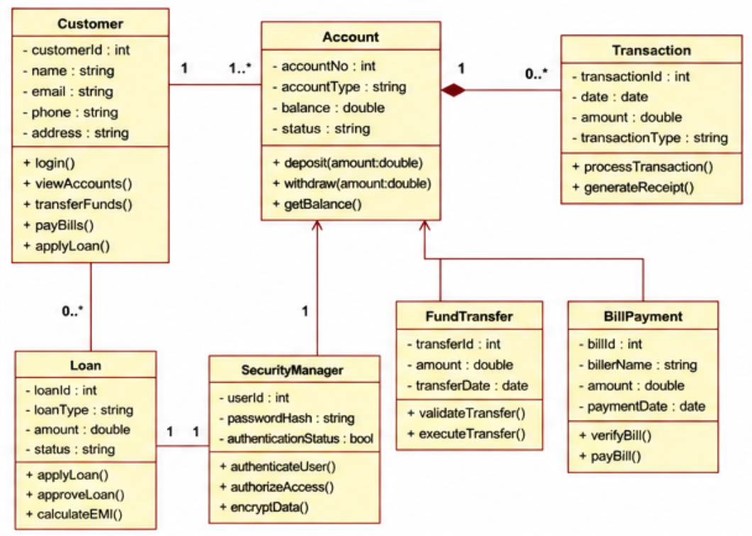
application and justify your choice.

FIG 1. CLASS DIAGRAM
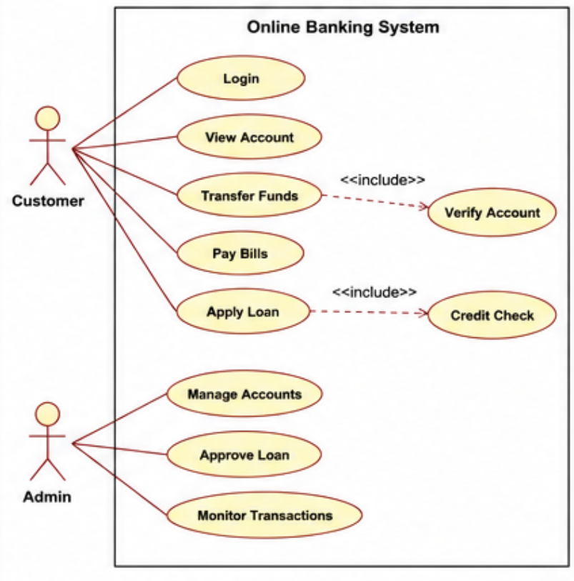

FIG 2. USE CASE DIAGRAM

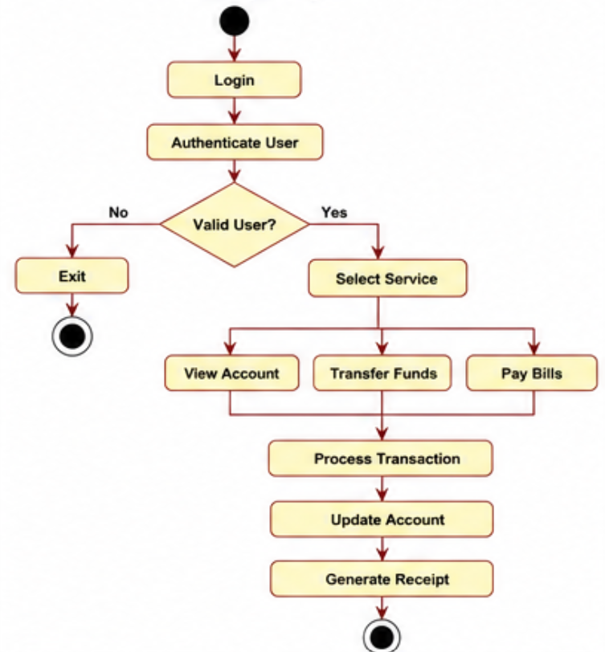

FIG 3. ACTIVITY DIAGRAM

b) Smart Library Management SystemA university library plans to automate its operations including book cataloguing, member registration,
book lending, return tracking, and overdue fine calculation. The system should support both physical
and digital book management.
Question: Apply object-oriented concepts to model this system. Identify appropriate classes,
relationships (association, aggregation, inheritance), and suggest how polymorphism can be used.
Select an SDLC model that suits an institution with defined, stable requirements and justify your
answer.

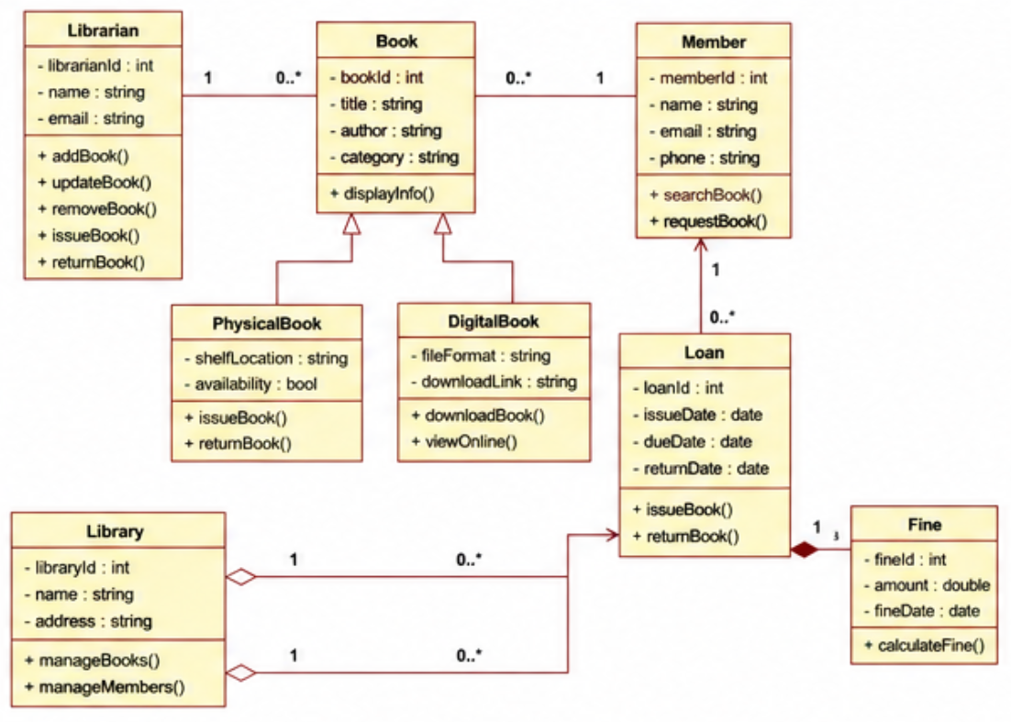
FIG 4. CLASS DIAGRAM

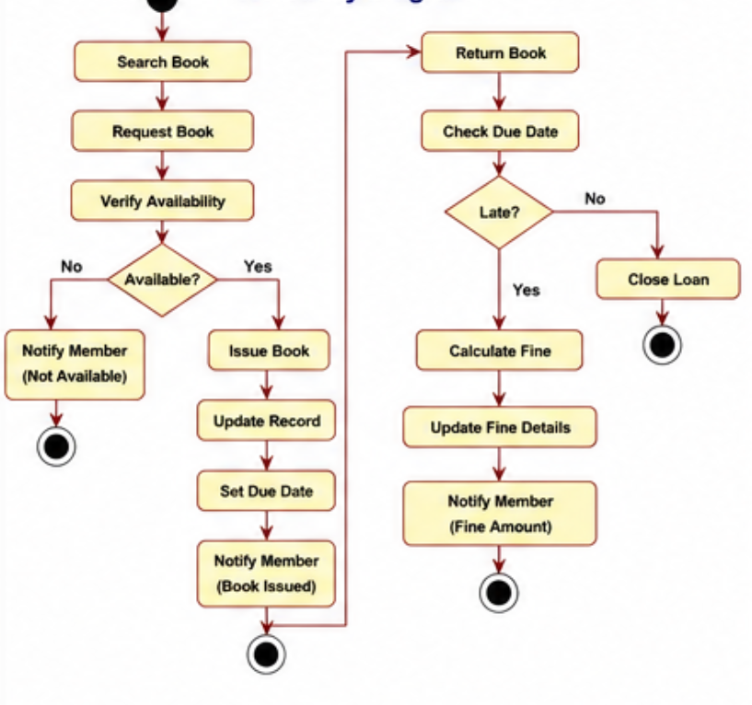

FIG 5. ACTIVITY DIAGRAM

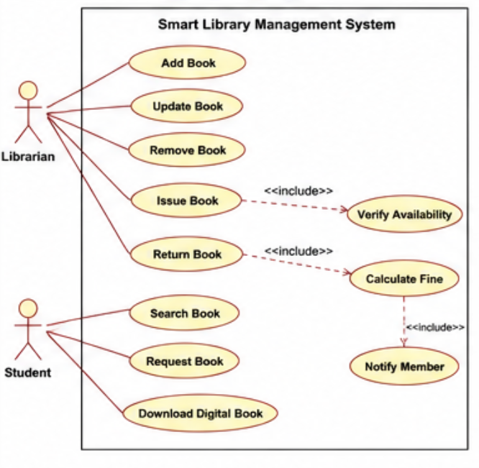
FIG 6. USE CASE DIAGRAM

